Section 1: Summary
The ransomware Mallox (also known as: Target Company, FARGO, or Tonichi) are strains of ransomware operating as a Ransomware as a Service Model (RaaS) starting in June 2021. It operates by using a brute-force dictionary attack on unsecure My SQL servers. The article puts together several attack graphs explaining the virus at various steps and how best to combat it. They have determined it starts by downloading Mallox through a PowerShell script. It then creates a local account and adds it to “Administrators” for your PC as well as “Remote Desktop Users”. It then goes after neighboring systems to attempt to infect any connected systems as well. In addition, it creates a rule on the firewall to allow remote access. Mallox then makes a bunch of Windows API calls to get more information on where and what it is on. Finally, it goes through and deletes security event logs and shadow copies in logs to prevent detection.
The article then goes into how to mitigate and detect the ransomware by using scripts to detect Invoke web requests and detecting deletion of shadow copies. Then it goes into preventing the encryption of files on the system that is effected by having an Antivirus or EDR detection ready as that is when it is optimal to catch the ransomware and prevent suspicious data exfiltration and encryption. Then the article wraps up by offering services to assist in security measures.
Section 2: Opinion/Analysis
This article was about Mallox and how to mitigate risk through detection and mitigation through defensive PowerShell prompts. The article’s intense detail on each aspect of the virus should allow anyone who needs to prevent Mallox from entering their systems to mitigate the risk associated with it. The full Tactics, Techniques, Protocol graphic and accompanying documentation of the emulated ransomware helps know where and how the ransomware attacks. The exact protocols used are laid out so a system administrator can easily set up checks to make sure they are not able to be infected easily.
The graphic shows 23 steps from initial contact to encryption and lays it all out in a nice, neat place. The article also goes over what exact commands and protocols are being abused by Mallox at each step of the process, cutting the chart into digestible chunks of information that is useful to a system administration who is worried about the ransomware. If I were a network administrator I would greatly appreciate the amount of work and dedication a full breakdown of the ransomware would have required and the step by step breakdown of the Mallox ransomware. The additional scripts to help mitigate risk were a nice touch by the author as well. I learned a bit about how the ransomware known as Mallox is run just by reading the attached article. They also linked MITRE ATT&CK articles to help find more ways to mitigate the potential threat.

Section 3: Screenshot of article (Part 2)
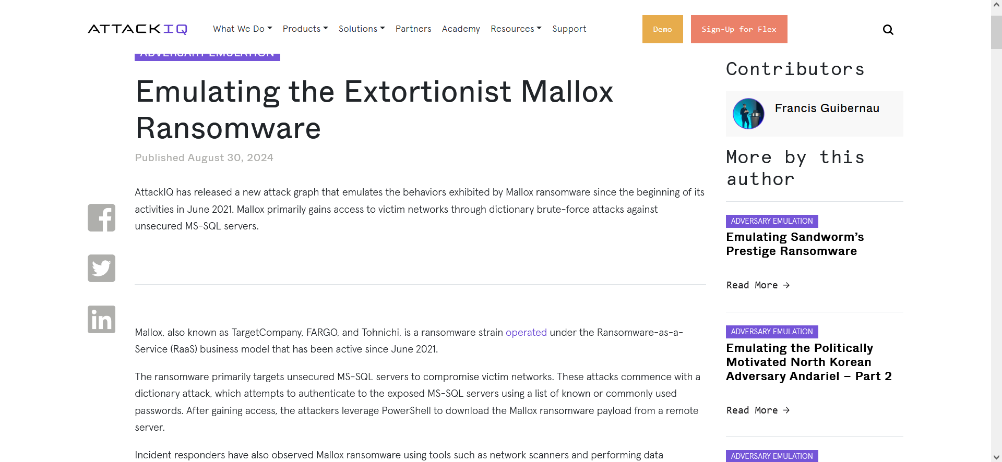

Section 4: Screenshot from Part 1
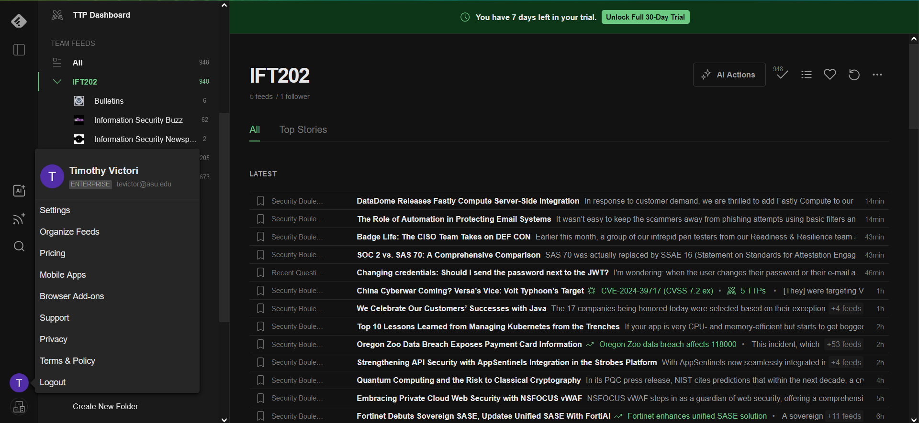

Section 5: References
- https://www.attackiq.com/2024/08/30/emulating-mallox-ransomware/

